**Python Data Structures**:

**Sets**:

A set is created by placing all the items (elements) inside curly braces {}, separated by comma or by using the built-in function set().

You can store all kinds of data types in same set like - in a single set you can store int, float, Boolean, string or another set whatever you want. In Set you cannot store duplicate value. For sets order does not matter. It means it doesn’t matter in what order you put the values. In set it can be showed in different order than you inputted order.

There are 2 fundamental use of Sets:

*Union*:

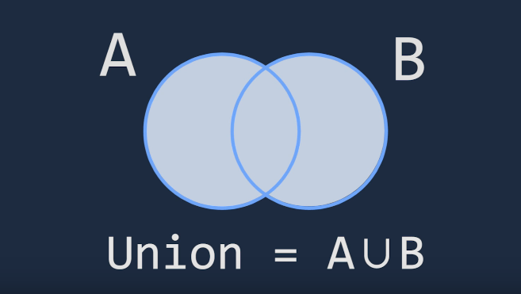

*Intersection*:

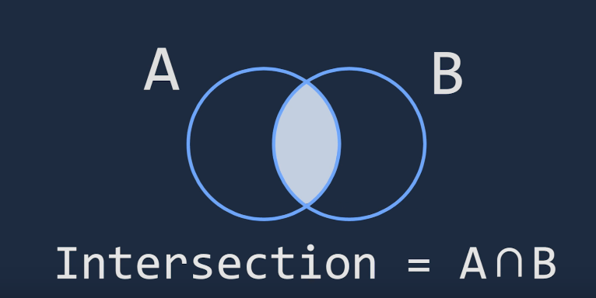

**List**:

The list type is a container that holds a number of other objects, in a given order. (**order matters**) Creating a list is as simple as putting different comma-separated values between square brackets or using the ‘list()’ constructor. But the most common way is using the square brackets. In python you can store multiple data types. Eg - L = [integer, float, Boolean, string, list]

['aam','jaam','kathal','komola','narikel','lichu']

|  |  |  |  |  |  |
| --- | --- | --- | --- | --- | --- |
| 0 | 1 | 2 | 3 | 4 | 5 |
| aam | jaam | kathal | komola | narikel | lichu |
| -6 | -5 | -4 | -3 | -2 | -1 |

*Slicing:*

If we want to print the items of position 2nd, 3rd and 4th then we can slice the list as [2:5]. Note that the starting position is just like we write but the ending position we have to write the position we want + 1. So, though we want data till 4th position. We write till 5.

**Dictionary**:

A common structure in Computer science is associative array or Map. In python it’s called Dictionary. It is nothing but a key-value pair. You can imagen input as key and output as value. We can create dictionaries by two ways. By using Carli braces {} or using dict() constructor. Dictionary are not ordered data.

**Tuple**:

Tuple is a sequenced data packed with first bracket (). Its behavior are almost same as list but it has lower memory size than because it has less available methods than lists.

|  |
| --- |
| Cannot be Changed (Immutable) |
| You can make it more quickly than List |

**Loops:**

**Functions:**